Experiment 9 “Hydroboration-Oxidation of 1-Hexene”

Hydroboration-Oxidation is a common technique used to convert an alkene into an alcohol. This reaction has two steps. The first step involves the BH3 molecule attacking the C=C double bond on the alkene. One H bonds to one of the carbon atoms and the BH2 forms a bond with the other. The second step is to oxidize the organoborane which forms the alcohol. In this experiment, 1-Hexene was used as the starting alkene and IR spectroscopy and GC analysis was used to identify the major and minor products.

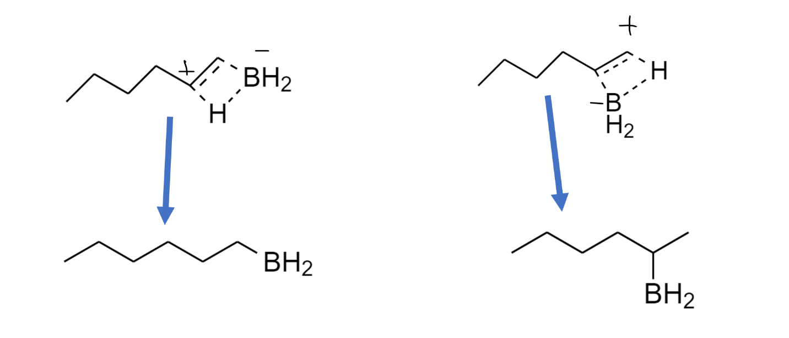 The original hypothesis was that the hydroboration step would follow anti-Markovnikov so the more stable intermediate alkylborane would have the BH2 bonded to the less substituted C. The reaction proceeds in this way for steric and electronic reasons. The BH2 bonds to the less substituted C because it is the more accessible C so the BH2 would be less sterically hindered. As for the electronic reason, although the mechanism involves a “concerted addition of H and BH2 from the same side of the planar double bond” (Smith 386) the bonds are not broken and formed at exactly the same time so there is a partial negative charge on B and a partial positive charge on one C as illustrated in Fig 1. The partial positive charge would be on the more substituted C because the positive charge is stabilized by alkyl groups. Therefore, the BH2 would bond to the C without the partial positive charge. The more stable intermediate would then be converted into the major product via the oxidation step.

Markovnikov (Higher Energy)

Anti-Markovnikov (Lower Energy)

Fig. 1

The hypothesis was confirmed by analysis of the GC data. The instrument recognized six different peaks with RTs outlined in Table 1. These RTs are similar to those found in the reference GC data provided in the procedure (Zharov 5). The first two peaks may represent Tetrahydrofuran (THF). In the reference data there is only one peak representing THF but the first peak in the experimental data is very small and close to the second peak so it is likely they represent the same molecule. There is a peak for 2-Hexanol but it is so small that the instrument did not calculate its area so its product ratio is neglected. This data shows that there was much more 1-Hexanol present in the product than 2-Hexanol which confirms the hypothesis because 1-Hexanol is the least substituted Alcohol.

|  |  |  |
| --- | --- | --- |
| *Table 1* | | |
| Molecule | RT (min) | Product Ratio (%) |
| THF | 2.13, 2.23 | 45.1 |
| 1-Butanol | 2.63 | 45.9 |
| 1-Hexanol | 6.16 | 6.09 |
| 2-Hexanol | ~5.2 | 0 |
| Other | 8.26, 8.59 | 2.84 |

The IR and GC data can both be used to infer the purity of the product. The IR data for 1-Hexene shows expected peaks correlating to the C=C and C-H bonds that make up the molecule. The C=C peak shows at around 1642cm-1 and the C-H peaks range from 2861 to 2959cm-1 with another peak at 3079cm-1 which represents the C=C-H bonds. The IR data for the product shows peaks at a similar range as the starting material for the C-H bonds from 2873 to 2957cm-1. Instead of a peak at 3079cm-1 however there is a broad peak at 3353cm-1 which represents the alcohol. There also appears to be a peak at 1727cm-1 which may correspond to a C=C double bond. If so, then there may have been some unreacted 1-Hexene leftover in the product. This peak could also represent THF because the GC showed that the product contained a high concentration of THF. In the GC data the actual “impurities” make up only 2.84% of the product which initially suggests that the product is pure. The majority of the product however, is not either of the Hexanol isomers, but THF. THF is included in the reaction solution because the BH3 that was used was provided as a BH3-THF complex but it does not take part in the reaction. When all the components of the product are considered, then the product ratio of the desired product was only about 6% which signifies that the product was highly impure. Even if the THF and 1-Butanol peaks are ignored, then the remaining product consists only of 1-Hexanol and impurities but the product ratio of the impurities is almost half that of 1-Hexanol which also indicates that the product was very impure. This analysis indicates that whether unreacted reactants are included or ignored, the product was fairly impure.

A large amount of THF was found in the product because the reaction between 1-Hexene and BH3-THF should be 1:1 but the number of moles of BH3-THF was about 6.5x that of 1-Hexene so assuming 100% of the 1-Hexene reacted, according to the values in the following table, there was still about 2.66e-2 moles of BH3-THF left in the solution. This suggests that much less BH3-THF could have been used to produce the same amount of Hexanol Isomers while having less THF leftover in the product. This suggestion would not necessarily affect the purity of the product.

|  |  |  |  |
| --- | --- | --- | --- |
| *Table 2* | | | |
|  | 1-Hexene* | 1M BH3-THFª | Hexanol Isomers* |
| MW (g/mol) | 84.16 | 85.94 | 102.17 |
| Density (g/mL) | 0.670 | 0.898 | 0.810 |
| Amount Used (mL) | 0.600 | 3.00 |  |
| Amount Used (mol) | 4.78e-3 | 3.13e-2 |  |
| Amount Obtained (g) |  |  | 0.307 |
| Amount Obtained (mol) |  |  | 3.01e-3 |
| \**values obtained from procedure (Zharov 4)*  *ªvalues obtained from sigmaaldrich.com* (*Borane tetrahydrofuran complex 1.0m tetrahydrofuran 14044-65-6*) | | | |

The %yield for the impure product was about 63%. However, as discussed previously, the product consisted mostly of unreacted reactants and only about 6% of the desired product. This implies that the %yield for the pure product is much less than 63% and is calculated to be only 3.83%. It is possible that this incredibly small %yield is due to the inaccurate separation of layers during the extraction step of the experiment. When 2mL of Et2O was added to the solution in a separatory funnel, two distinct layers were not readily observed. It is possible that much of the desired product was drained out of the separatory funnel along with the aqueous phase and discarded. Since the two layers were not distinguishable, it is also possible that some of the aqueous phase was not drained entirely from the separatory funnel but remained in the product. The first scenario would explain the %yield of the impure product but it does not explain how impure the product was. Therefore, the second scenario is the more likely because 63% is not abnormal for a %yield but it would explain the abnormal concentration of impurities in the product.

One way to improve the %yield would be to use less BH3-THF. Theoretically, only about 0.457mL would be needed for 100% of the 0.60mL of 1-Hexene to react. This adjustment would decrease the amount of THF used in the reaction so it would be less prominent in the final product. If it is preferred that BH3-THF is the limiting reactant, then an acceptable amount to add could be 1-2mL instead of 3mL. Using just 1mL would supply about 1.04e-2 moles to the reaction which is more than twice the amount that is theoretically needed so there should still be plenty of BH3. Another improvement to the experiment would be to give the aqueous and organic layers more time to separate in the separatory funnel before trying to drain the aqueous layer.

As suggested by the GC and IR data and the theory governing this reaction, the major or anti-Markovnikov product was the less substituted alcohol while the minor or Markovnikov product was the more substituted alcohol. The product was not very pure and only a small amount of the expected product was obtained but the reaction itself proceeded as expected and 1-Hexanol was produced.

References

“Borane Tetrahydrofuran Complex 1.0m Tetrahydrofuran 14044-65-6.” *1.0 M In THF | 14044-65-6*, https://www.sigmaaldrich.com/US/en/product/aldrich/176192.

Smith, Janice Gorzynski. *Organic Chemistry*. Third ed., McGraw-Hill, 2011.

Zharov, Ilya, *Hydroboration/Oxidation of 1-Hexene*. October 2021.